Python Variables
Variable is a name of the memory location where data is stored. Once a variable is stored that means a space is allocated in memory.

Assigning values to Variable:
We need not to declare explicitly variable in Python. When we assign any value to the variable that variable is declared automatically.
The assignment is done using the equal (=) operator.
Eg:

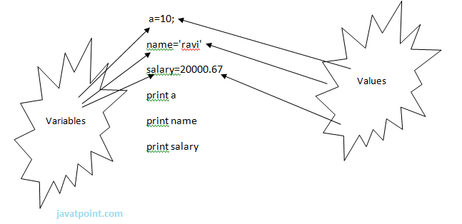
Output:
- >>>
- 10
- ravi
- 20000.67
- >>>

Multiple Assignment:
Multiple assignment can be done in Python at a time.
There are two ways to assign values in Python:
1. Assigning single value to multiple variables:
Eg:
- x=y=z=50
- print x
- print y
- print z
Output:
- >>>
- 50
- 50
- 50
- >>>
2.Assigning multiple values to multiple variables:
Eg:
- a,b,c=5,10,15
- print a
- print b
- print c
Output:
- >>>
- 5
- 10
- 15
- >>>
The values will be assigned in the order in which variables appears.

Basic Fundamentals:
This section contains the basic fundamentals of Python like :
i)Tokens and their types.
ii) Comments
a)Tokens:
- Tokens can be defined as a punctuator mark, reserved words and each individual word in a statement.
- Token is the smallest unit inside the given program.
There are following tokens in Python:
- Keywords.
- Identifiers.
- Literals.
- Operators.

Tuples:
- Tuple is another form of collection where different type of data can be stored.
- It is similar to list where data is separated by commas. Only the difference is that list uses square bracket and tuple uses parenthesis.
- Tuples are enclosed in parenthesis and cannot be changed.
Eg:
- >>> tuple=('rahul',100,60.4,'deepak')
- >>> tuple1=('sanjay',10)
- >>> tuple
- ('rahul', 100, 60.4, 'deepak')
- >>> tuple[2:]
- (60.4, 'deepak')
- >>> tuple1[0]
- 'sanjay'
- >>> tuple+tuple1
- ('rahul', 100, 60.4, 'deepak', 'sanjay', 10)
- >>>

Dictionary:
- Dictionary is a collection which works on a key-value pair.
- It works like an associated array where no two keys can be same.
- Dictionaries are enclosed by curly braces ({}) and values can be retrieved by square bracket([]).
Eg:
- >>> dictionary={'name':'charlie','id':100,'dept':'it'}
- >>> dictionary
- {'dept': 'it', 'name': 'charlie', 'id': 100}
- >>> dictionary.keys()
- ['dept', 'name', 'id']
- >>> dictionary.values()
- ['it', 'charlie', 100]
- >>>

